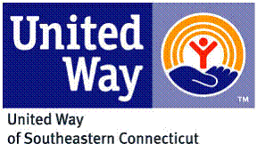

United Way of Southeastern Connecticut
Acknowledgement of FY21 Allocation Award Letter
& Required Documentation Notice
Receipt of funding is contingent upon signing this acknowledgment

All funding is contingent upon the availability of funds and the agency’s ability to provide quality service to program participants. This document is not a guarantee of funding. United Way of Southeastern Connecticut may adjust the amount of funds allocated to a program after its annual year-end audit or at other times during the fiscal year due to changes in the amount of funds received by United Way. Furthermore, should it be determined that funds were not used as specified by the agency during the allocations process, the United Way Board of Directors reserves the right to reclaim funds that were distributed.

I have read and understand United Way of Southeastern Connecticut’s Allocation Award Letter and the required documentation and due dates for partner agencies and agree to comply. Failure to sign this document will delay disbursement of funds.

Agency:

Signature of CEO/ Executive Director Date

Signature of Board President Date

Please email this signed document by July 8, 2020 to:

Scott Umbel
Community Impact Director
scott.umbel@uwsect.org

