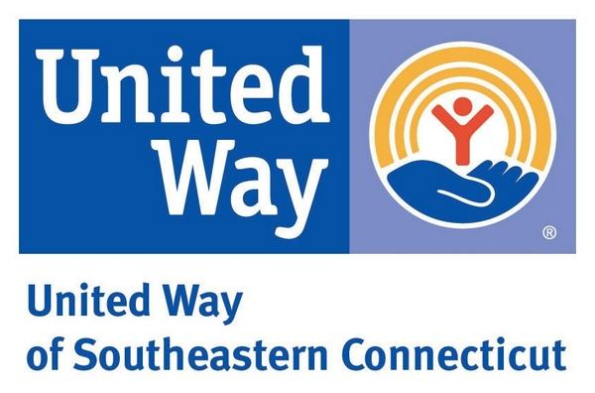

UNITED WAY OF SOUTHEASTERN CONNECTICUT
JOB DESCRIPTION

Title: Grant Compliance Associate
Reports to: Vice President of Community Impact
Department: Community Impact
FLSA Status: Part-Time
Revision Date: July 29, 2020

POSITION SUMMARY:
Under the supervision of the Vice President of Community Impact this position will provide grant and contract administrative support in the Community Impact Department at United Way of Southeastern Connecticut (UWSECT). Two primary focuses will be financial review of agency submissions and grant compliance. Weekly financial assistance requests are submitted by contracted agencies for homelessness client support. The Associate will review these requests against funding standards, gather documentation from the vendor, and coordinate with the Finance Department to issue payments.

For compliance tasks, this position will assist with data and documentation requirements for multiple homelessness grants at the local and state level that are administered by United Way; communicate with separate, non-profit agencies to meet monthly and quarterly financial and data reporting requirements, collate data, thoroughly review financial documents, request corrections, and submit to the Community Impact Director in a timely fashion.

Additional duties will include data management and reporting for United Way grants, duties integral to outcome measurement in Community Impact, and other functions related to UWSECT community impact work.

This position will be responsible in supporting reporting and compliance needs for the following UWSECT managed grants and funds:

New London County Fund to End Homelessness: A $285,000 grant from Department of Housing (DOH) that supplies small admin funds to UWSECT and five sub-contracted provider agencies that expend the $220k+ in client financial assistance funds for shelter diversion and rapid-rehousing out of shelters.

Community Development Block Grant (CDBG) – Small Cities: A $350,000 fund that provides direct salary compensation to five sub-contracted provider agencies to expand the number of shelter diversion case workers in our region and ultimately increased diversion capacity.

Eastern Coordinated Access Network (ECAN): A collaborative group of homeless shelter and support agencies across Eastern Connecticut. UWSECT operates as their fiduciary of pass-through funds from DOH to the CAN.

*Other grants and funds as assigned.

KEY ROLES & RESPONSIBILITIES:
Financial Assistance Review
- On a daily basis, review financial assistance requests in the state’s Homeless Management Information System (HMIS).
- Possess or gain proficiency in HMIS, Excel financial reporting, and UWSECT’s own accounting systems after provided training.
- Meet documentation requirements of each funding category, assess the identified vendor documents, and issue approvals when in compliance.
- Coordinate vendor payments with the Finance Department to ensure assistance funds are issued within one-week of the request date.
- Communicate consistently with the Community Impact Director to manage the balance of funds to support communication with contracted program providers.
- Provide data and tracking on all requests across funding categories.

Grant & Compliance Coordination
- Review submitted financial documents and reports from contracted agencies to ensure they meet the requirements of each program fund.
- Thoroughly assess each submission, coordinate with the agency contact for corrections, track in UWSECT’s internal tracking systems, and submit to the appropriate program office at the local or state level.
- Collate data from various sources to input to existing report templates.
- Assist in completing local and state compliance documents and audits.
- Track reporting timelines for all programs within responsibility.
- It is critical that these tasks are consistently coordinated with the Community Impact Director.

Other
- Assist in data and reporting management in other funds and grants.
- Perform other duties as assigned.

QUALIFICATIONS, EDUCATION, AND SKILL REQUIREMENTS:
- High School Diploma or GED.
- Secondary Education certificate or degree preferred.
- At least 1-year of experience in financial and/or performance data management, preferably in non-profits.
- Demonstrated ability to thoroughly review and comprehend complex contracts, instructions, and reports.
- Skilled in use of MS Office products, in particular Excel; experience in setting up tables, basic addition formulas, and inputting to existing templates.
- Ability to interpret, analyze, and problem solve reporting tasks.
- Ability to complete business and financial math problems; addition, percentages, etc.
- Proven written and verbal skills.
- Ability to clearly communicate with colleagues and outside organizations.
- Project a professional image and the ability to work harmoniously with others.
- This position may not have a direct connection to an agency that is funded by grants or UWSECT funds that this role provides support to; employee, volunteer, board member, participant.

EMPLOYMENT
- This position is grant-funded. Should grant funds not be available, this position may be terminated with notice.
- This position may need flexibility in hours of work with prior notice and planning.

I have read, understand, and accept this Job Description:

_______________________________________________________________________________________________________________
Employee Signature Date

United Way of Southeastern Connecticut is an Equal Opportunity Employer.

